**User Guide**

**Installing Citrix and Opening Database View**

*The following is a guide on how to properly install Citrix and The Raiser’s Edge on your workspace. This walkthrough requires access to Raiser’s Edge NXT.*

***The examples used in the screenshots may visually vary from your actual experience.***

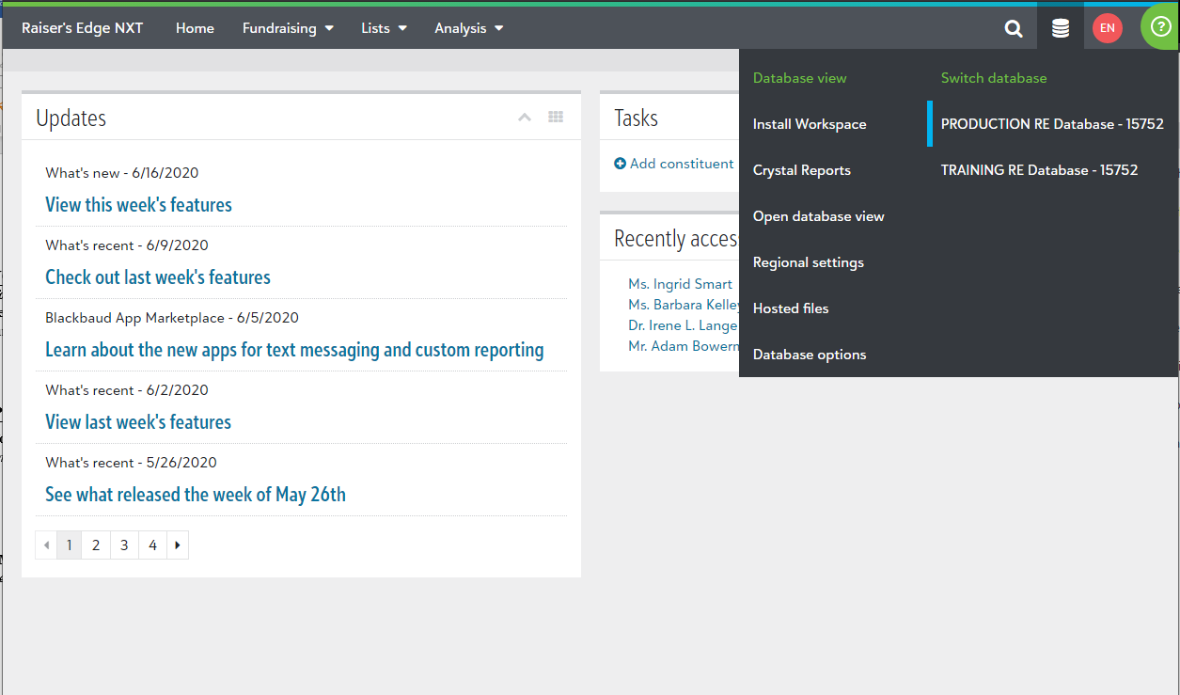At the top of Raiser’s Edge NXT, click on the stack of pancakes(?) at the top right corner of the screen. Afterwards, click on ‘Install Workspace’.

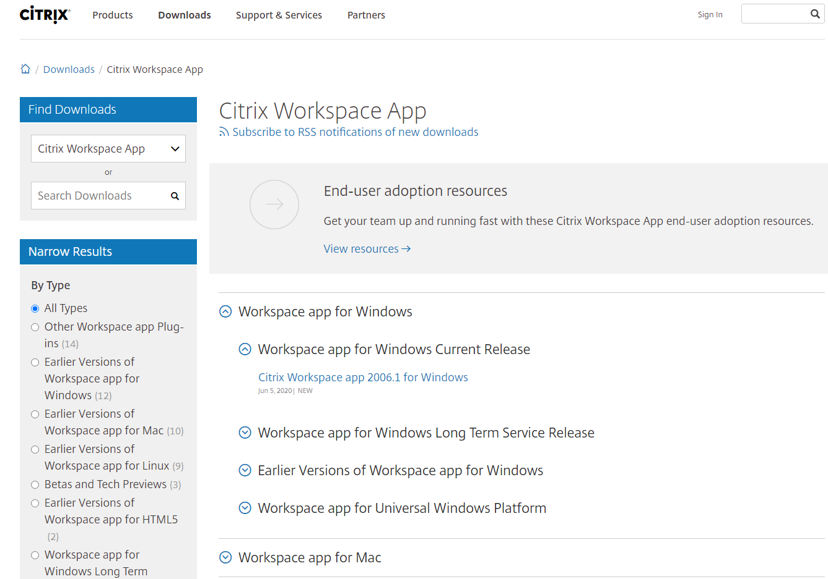You should now be redirected to the Citrix download webpage. Select the download based on your operating system.

*For example, if your workspace computer is running Windows then you would click on the hyperlink under ‘Workspace app for Windows Current Release’.*

After clicking on the appropriate hyperlink, click on the Download button. Your finished download should appear at the bottom left corner of the screen. Click on it to begin the installation process.

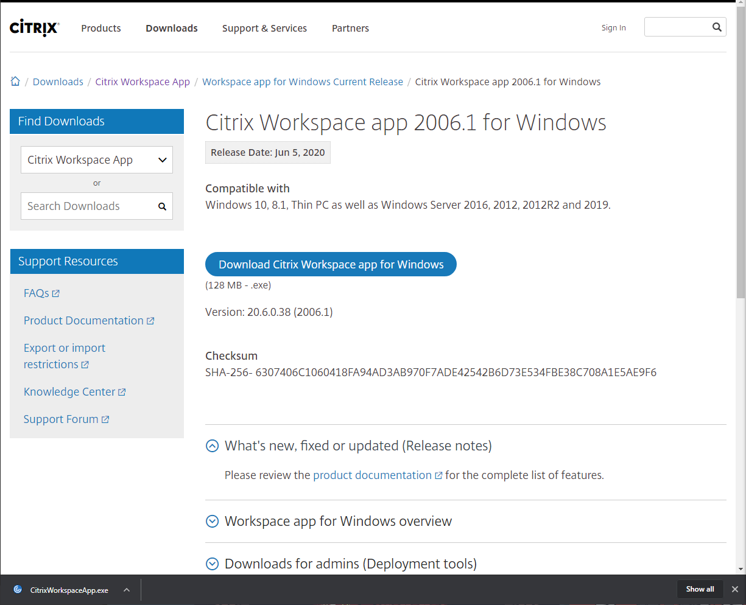

*Note: Your device may ask for permission to allow the installation. Simply accept the request.*

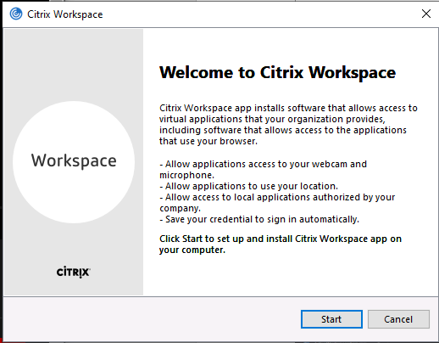Complete the installation process.

When you get to this part of the installation, make sure that the box is NOT checked.

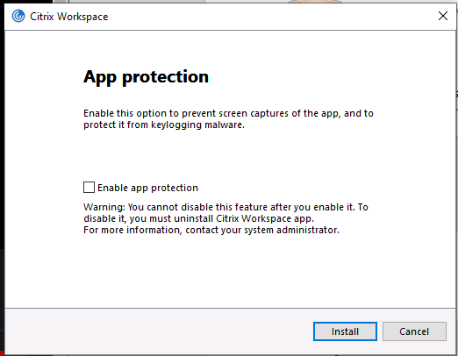

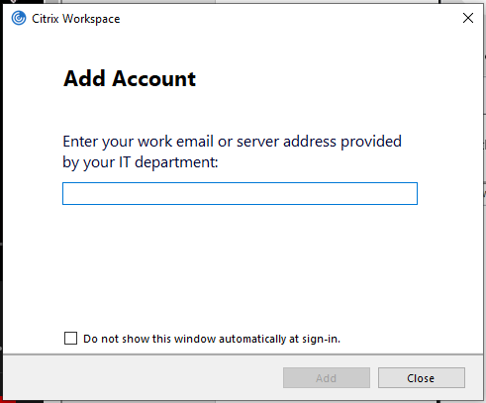After the installation process is complete, a pop-up window will appear. Simply ignore it for now.

On your web browser, return back to Raiser’s Edge NXT and select the stack of pancakes at the top right corner. Click on ‘Open database view’. This will begin a download at the bottom left corner. Click on it to launch the database.

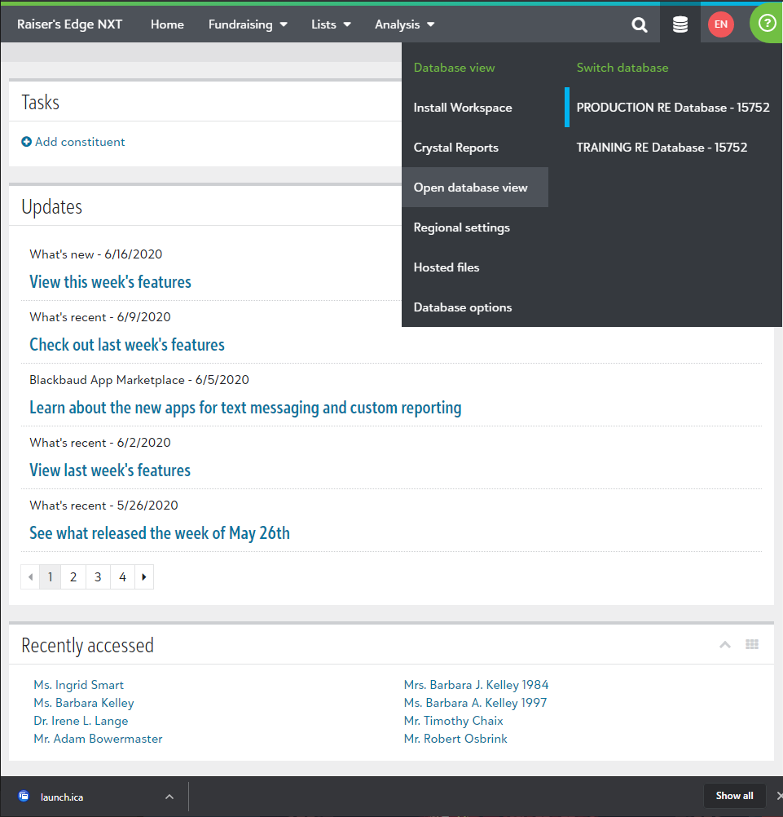

The Database view will take a moment to start. After it initializes, you will have access to The Raiser’s Edge.

